

**Department of**

**Computer Science & Engineering**

**Lab Report**

**Course code :** CSE 312

**Course title :** Object-oriented analysis and design.

**Experiment no :** 04

# **Experiment name :** Identifying Subsystems and Use Case Scenarios for Use

# Case Diagram.

# **Date of Submission:** June 20, 2022

**Group NO :** 02

**Group members :**

| **Sl** | Class Roll | Name |
| --- | --- | --- |
| 01 | 342 | Tama Shil |
| 02 | 362 | Umme Faria Moon |
| 03 | 367 | Ahsan Habib Rasel |
| 04 | 375 | Pritam Saha |

**Subsystem-1**

**Actor:** Customer, Admin.

**Scenario:**

* Customer will Login into system.
* Customer will Register into system.
* Admin will Login into system.

**Exception:** Login page not found.

**Precondition:** Login page from web browser.

**Postcondition:**

* Successful Login
* Unsuccessful Login
* Page not found.

**Use case relation:**

1. Include
2. Extends

**Use case Diagram:**

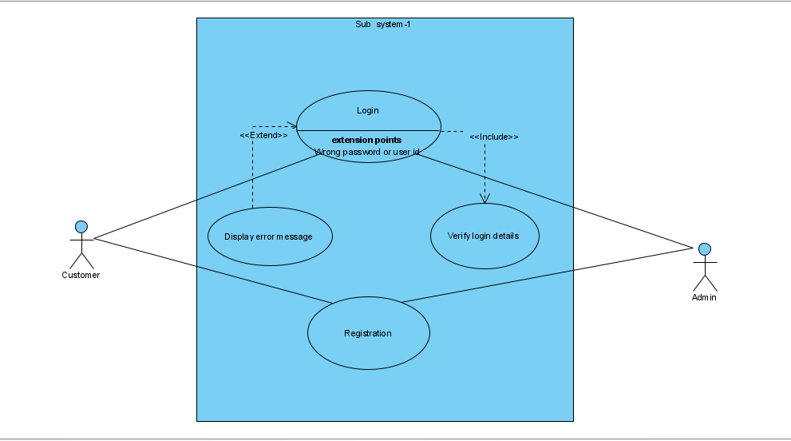

**Subsystem-2**

**Actor:** Admin.

**Scenario:**

* Admin will add bus details.
* Admin will input pickup points of all buses so that customer can select pickup points.
* Admin will input bus route and bus name so that these information can be provided to the customer.

**Exception:** Web page not found.

**Precondition:**

* Pickup points must be set according to pick up point and time.
* One time must be provided to one bus at a time.
* Route must be set according to correct route and one bus name must be provided to one bus.

**Postcondition:**

* Admin can provide one pickup time for one bus.
* Admin can provide one bus name and route at a same time.

**Use case relation:**

1. Include relation in pickup point about selecting unique time for one bus at a time.
2. Extend relation for notifying about the collision of bus.

**Use case Diagram:**

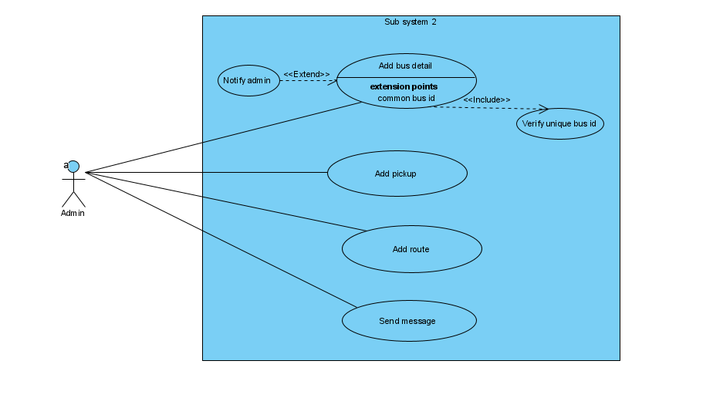

**Subsystem-3**

**Actor:** Customer, Admin.

**Scenario:**

* Customer will do the reservation of buses.
* Both Admin and Customer can send message to each other.
* Customer will do payment.

**Exception:** Wrong customer information.

**Precondition:** Only registered customer can reserve ticket.

**Postcondition:**

* Admin will get a notification about a seat being reserved.
* Customer will get a confirmation notification.

**Use case relation:**

1. Include
2. Extends

**Use case Diagram:**

